27 March 2019 PR No.: 04/2019

Super compact implement carrier with petrol or diesel engine

Large compact class: The Holder X 45
The Holder X 45 brings a comprehensive range of features and numerous innovations to the 45 HP class. Holder already now provides a solution to the particulate matter problem that many cities are facing with the option of diesel or petrol engines (X 45i). A maximum speed of 27 km/h makes the X 45 the fastest machine in the series. Up to 1,025 kg payload and 2,300 kg permissible total weight make it a leader in this class. The Holder X 45 safely brings its power to the road any time thanks to a low centre of gravity and permanent all-wheel drive.
The intelligent dynamic drive control enables automatic control of the drive pump in relation to load and speed, thus guaranteeing ideal traction even on steep slopes. The core applications (vacuum sweeping, mower vacuum, irrigation and winter maintenance) can be easily selected via a programme switch. Depending on the application, this automatically ensures demand-driven hydraulic power and provides excellent results.
The driver's cab is one of the most spacious in its class and sets the standard in terms of comfort and ease of use. For instance, it has an adjustable armrest mounted to the air-suspended driver's seat, a large Holder joystick for comfortable one-handed operation, exits to the right and left, a sash window, as well as effective sound insulation. Numerous comfort and safety customization options make the driver’s life easier (e.g. rear and suction nozzle cameras).
The most widely used application in this segment is sweeping. Holder provides a separate sweeping-vacuuming combination which integrates seamlessly with the carrier vehicle and also boasts numerous benefits. As is typical with Holder, high-quality attachments for year-round applications are also included in the X 45 range.

Reprint is free, request sample copy
1,768 characters with spaces

Max Holder GmbH
Max Holder GmbH is one of the leading manufacturers of multifunctional system vehicles for winter maintenance, path and road cleaning, the upkeep of green areas, as well as for numerous special applications. The long-established Baden-Württemberg company founded in 1888 offers professional complete solutions and individual services from a single source together with more than 250 sales and service partners worldwide.

Company contact details
Mahdenstr. 8
72768 Reutlingen
Telephone: +49 7121 930729-0
Fax: +49 7121 930729-213
Franziska Reiche
Head of Marketing & Communication
f.reiche@max-holder.com
Telephone: +49 7121 930729-281

Captions
Photos (1): Max Holder GmbH

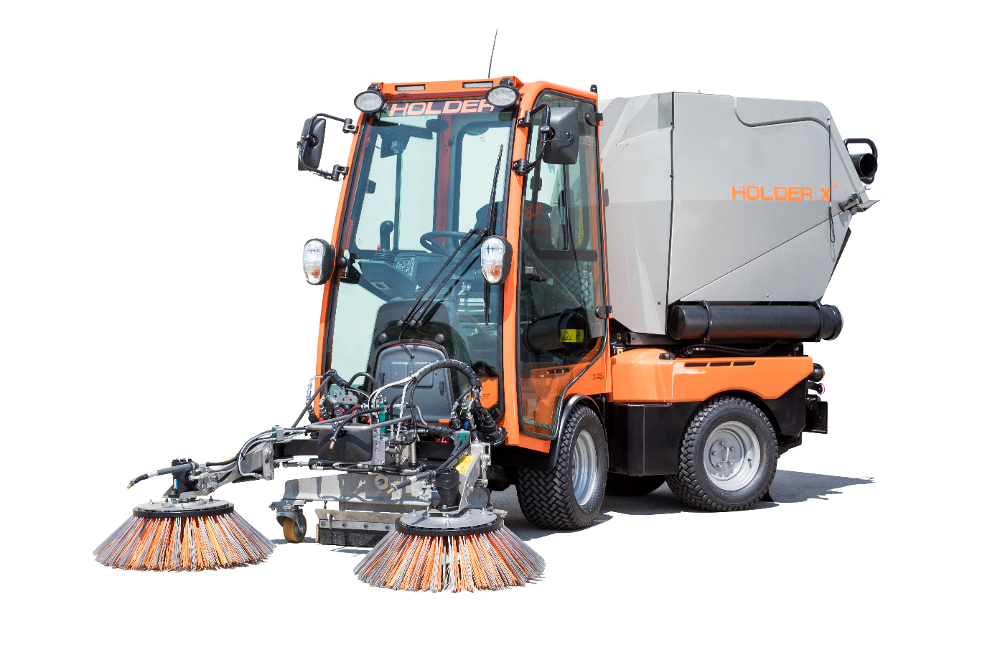
Holder X 45: The multifunctional articulated machine can not only sweep, but is also ideal for the upkeep of green areas and winter maintenance.

