26th August 2019 PR No.: 08a/2019

Reliable technology for safety on the roads
Holder implement carriers used in winter maintenance
Whether municipal fleet operators, private contractors, industrial enterprises or real estate companies – every winter, many organisations are faced with the question of how they can manage their winter service tasks with an intelligent combination of carrier vehicles and attachments in the most reliable, efficient and cost-effective manner.
With its range of premium vehicles from 45 to 130 HP, Holder offers a wide variety of implement carriers for winter maintenance. Light to medium clearing and spreading tasks can be reliably handled with the articulated multi-functional tractors from the X, B and C series, or also using the MUVO with four-wheel steering. For heavy duty use, particularly in snowy and alpine regions, the powerful models from the S series are an especially attractive option. A variety of snow shields, snow blowers and spreaders can be attached to any model via the standardised interfaces without any hassle. Thanks to many years of close collaboration between Holder and its premium partners, vehicles and attachments are perfectly coordinated to one another, allowing you to benefit from a technically flawless, efficient and long-lasting complete system.
Customers particularly value the articulated steering on Holder products. With this, it is possible on the one hand to swerve around obstacles in even the tightest of spaces, and on the other to ensure that an attachment such as a snow shield or snow blower can be easily and optimally aligned via the steering. Thanks to the three-dimensional adjustment, all surrounding variables can be appropriately responded to. The floating position, which allows for an even distance from the ground to be maintained, consequently preserving the attachments and ensuring a longer service life, is another important element. The intelligent load limit control is particularly effective for snow blowers, as it ensures that the travel speed is automatically adapted to the reduction in capacity on the front attachment. To ensure that the drivers can also perform at their full capacity in minus temperatures and over extended periods of operation, the Holder comfort cabins have optimal thermal insulation, a powerful heating system and winter-appropriate equipment such as seat heating, air conditioning and a heated front windscreen and exterior mirror. Good accessibility for servicing is also guaranteed by Holder through elements such as the side hatches, which ensure that the batteries and fuse can be reached with relative ease.
The vehicles from Holder are multifunctional units that can be deployed all year round. This means that it is possible to convert them for a extremely wide variety of additional applications, whether they are needed for grounds maintenance, for sweeping and cleaning, for transportation tasks or for numerous other special applications.

Reprint is free, request sample copy
2,848 characters with spaces

Max Holder GmbH
Max Holder GmbH is one of the leading manufacturers of multifunctional system vehicles for winter maintenance, path and road cleaning, the upkeep of green areas, as well as for numerous special applications. The long-established German company founded in 1888 offers professional complete solutions and individual services from a single source together with more than 250 sales and service partners worldwide.

Company contact details
Mahdenstr. 8
72768 Reutlingen
Germany
Telephone: +49 (0) 7121 930729 0
Fax: +49 (0) 7121 930729 213
Franziska Reiche
Head of Marketing & Communication
f.reiche@max-holder.com
Telephone: +49 (0) 7121 930729 281

Captions
Photos (2): Max Holder GmbH

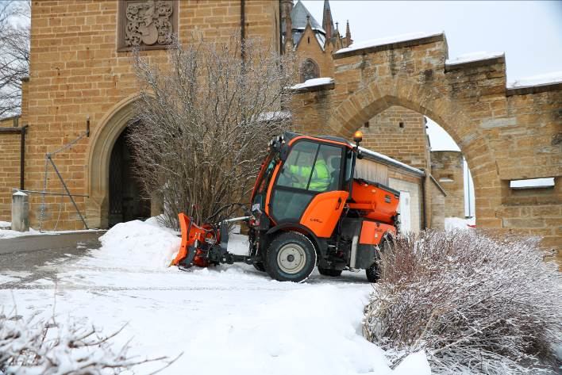
Holder C 65 with snow plough shield and spreader – overcomes even particularly steep gradients on slippery terrain

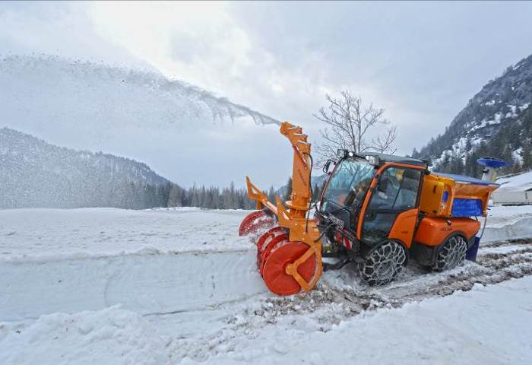
Holder S 130 with snow blower and spreader – heavy and hard snow masses require maximum performance from implement carriers and attachments

