Municipal equipment brands under one roof

**Kärcher Municipal GmbH bundles portfolio for municipalities**

|  |
| --- |
| **Press Contact** |
| David Wickel-Bajak |
| Head of Press Relations and Publicity |
| Alfred Kärcher SE & Co. KG |
| Alfred-Kärcher-Str. 28-40 |
| 71364 Winnenden |
|  |
| Tel. +49 71 95 14-2309 |
| david.wickel-bajak@de.kaercher.com |

**Winnenden / Reutlingen, *Date*** – In order to serve customers in the area of municipal equipment in a more targeted manner, with its specially created Municipal GmbH, Kärcher has now established a specialised competence centre. The Max Holder brand, which has belonged to the group of companies since 2019, has also been operating under this name since 1 January 2021. Michael Häusermann, Chairman of the Board for special business units at Alfred Kärcher SE & Co. KG, explains: "With the new company unit, we can make even greater use of synergies in order to support municipal users as a strong partner on the way into the future."

Kärcher Municipal GmbH operates as a legally independent division within the Kärcher Group at the Reutlingen location. Central functions such as sales, product management, purchasing and development are being merged. "In future, we will be present on the market with a complete portfolio for municipal outside cleaning and care," says Häusermann. One of the most important topics is the further development of sustainable mobility concepts. Also under the new organisation, the Holder and Kärcher brands will be visible with their respective competences. "We want to gain momentum and at the same time ensure continuity, states Häusermann. "So the team will also be maintained with its expertise and know-how."

A Word file and printable images for this press release are available to download in our Newsroom [https://www.kaercher.com/press](https://www.kaercher.com/presse).



*The newly created Kärcher Municipal GmbH bundles the complete portfolio for municipalities.*

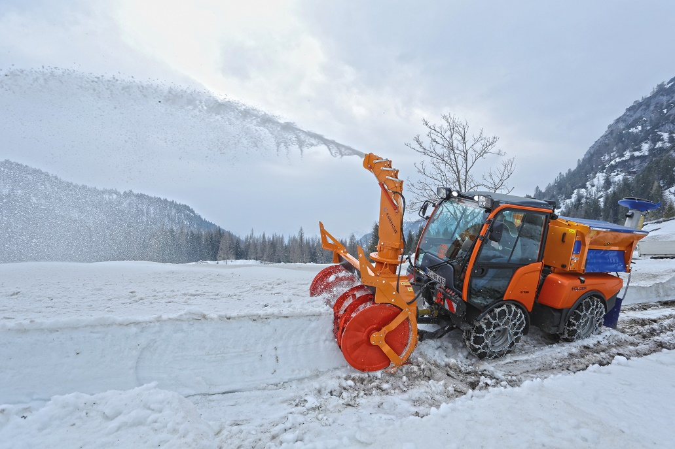

*Also under the new organisation, the Holder and Kärcher brands will be visible with their respective competences.*